How does the Geotab system calculate idling time?
Idling occurs when the engine is running, but the vehicle is not changing position. Idling that occurs before a trip starts is included as part of the idling for the previous trip. Please review the examples below to help understand how idling time gets attributed to particular trips.

Examples

Example — Time Spent Idling Before and After Driving
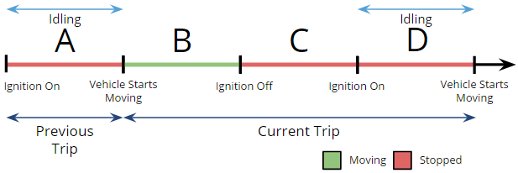
In this example, let’s assume time A and D are times spent idling. Therefore:revious trip idle time = A
Current trip = B + C + D
Current trip idle time = D

Example — Time Spent Idling in One Trip
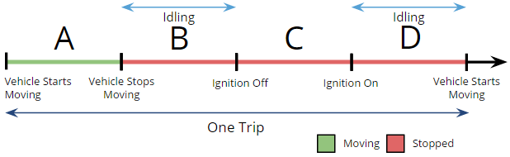

In this example, let’s assume time B and D are times spent idling. Therefore:
Current trip = A + B + C + D
Current trip idle time = B + D

Example — Time Spent Idling During Two Trips
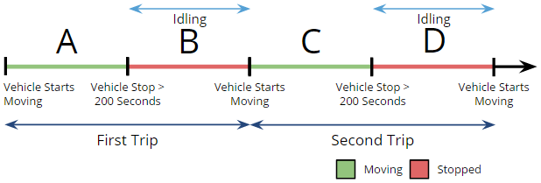
In this example, A+B is the first trip, and C+D is the second trip. The idle times are B and D where B is attributed to the first trip, and D is attributed to the second trip.

